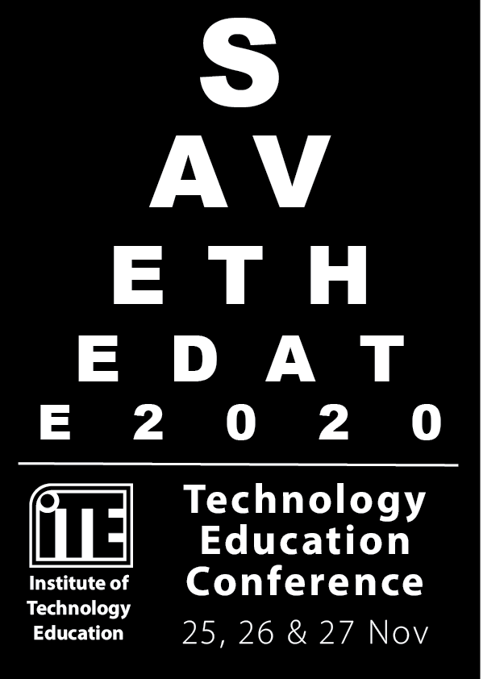
Institute of Technology Education

The content presented at this conference relates directly to the teaching of STEM, Technology, Engineering and Industrial Arts curriculum.

Over the three days of the conference Teachers are provided with the opportunity for networking, resource sharing, skill development and advancement, and to be kept abreast of current and future directions in STEM education, focusing on Engineering, Technologies, Industrial Arts and/or TAS.

https://www.itensw.com.au/event-3765873

Your ITE membership must be current to receive discounts on Conference tickets.
Not yet a member? Please contact our membership admin admin@iiate.asn.au for information on how to join.
Completing ITE Technology Education Conference Day 1 ‘Hands on Technology’ will contribute 6.5 hours of NSW Education Standards Authority (NESA) Registered PD addressing 6.2.2, 6.3.2 from the Australian Professional Standards for Teachers towards maintaining Proficient Accreditation in NSW.
Completing ITE Technology Education Conference Evening 1 will contribute 2.5 hours of NSW Education Standards Authority (NESA) Registered PD addressing 6.2.2, 7.4.2 from the Australian Professional Standards for Teachers towards maintaining Proficient Accreditation in NSW.
Completing ITE Technology Education Conference Day 2 will contribute 6.5 hours of NSW Education Standards Authority (NESA) Registered PD addressing 6.2.2, 6.3.2 from the Australian Professional Standards for Teachers towards maintaining Proficient Accreditation in NSW.
Completing ITE Technology Education Conference Evening 2 will contribute 2.5 hours of NSW Education Standards Authority (NESA) Registered PD addressing 6.2.2, 7.4.2 from the Australian Professional Standards for Teachers towards maintaining Proficient Accreditation in NSW.
Completing ITE Technology Education Conference Day 3 will contribute 6.5 hours of NSW Education Standards Authority (NESA) Registered PD addressing 6.2.2, 6.3.2 from the Australian Professional Standards for Teachers towards maintaining Proficient Accreditation in NSW.
There is no GST component in the cost of the conference as the ITE is exempt from GST |  | 1 day rate (any day) | 2 day rate (any two days) | 3 day rate | Conference Welcome | Conference Dinner
Early bird  (Members only) | Payment received by August 14th | $320 | $520 | $720 | $100 | $110
Standard  Member | Payment received by Nov 11th | $420 | $620 | $820 | $110 | $120
Non-Member |  | $470 | $670 | $870 | $120 | $130
Late  Member | Payment received after Nov 11th | $520 | $720 | $920 | N/A | N/A
Non-Member |  | $570 | $770 | $970
Student | Payment received before Nov 11th | $100 | $200 | $300 | $100 | $120
Guest | Payment received before Nov 11th |  |  |  | $110 | $120

CONFERENCE EVENT SCHEDULE:
There are FIVE events across three days that can be ticketed separately or bundled at a saving. Guests are welcome to attend the evening events (extra tickets can be added to orders).
Wednesday 25th November: Day One
‘Hands On’ Technology - An all day immersive session allowing attendees to learn, practice and embed by focusing on one area for the whole day. Locations vary, they are based on the workshop as some require specialist materials and are run by our partner organisations.
9:00 – 4:30pm (8:15am for first day registration)
Wednesday 25th November: Conference Welcome Evening
A collegial event that focuses on networking with finger food.
6:00pm – 10:00pm

Thursday 26th November: Day Two
Mix of short workshops, keynotes, presentations and our interactive Tech Expo. The workshops have limited numbers and are only available for selection once payment is made.
9:00am – 4:30pm (8:15am for first day registration)

Thursday 26th November: Conference Dinner
A three-course dinner event including guest speakers and annual award presentations.
6:30pm – 10:30pm
Friday 27th November: Day Three
Mix of short workshops, keynotes, presentations and our interactive Tech Expo. The workshops have limited numbers and are only available for selection once payment is made.
9:00am – 4:30pm (8:15am for first day registration)

General Conference Enquiries:
Astrid Perdriau - conferenceITE@gmail.com

